**Create a low level program.**

When me and my group opened ATP ‘Assembler Training Program’ we tried to start the program But there was an error, In the error report box it said it was on line 8 and 9 which isn’t the right thing.

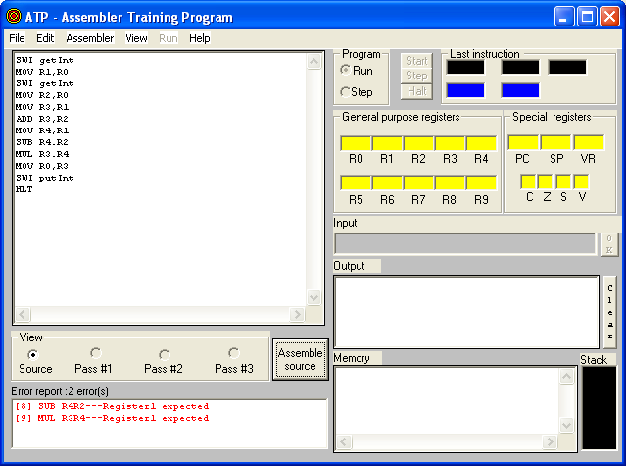

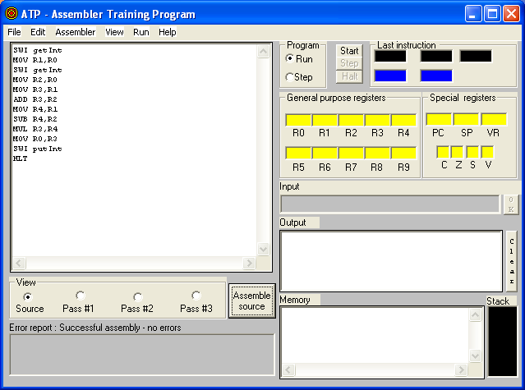

The reason why the errors kept coming was because I put a full stop (.) in the lines 8 and 9 instead of a coma (,) like the rest of the lines that’s why it didn’t work.

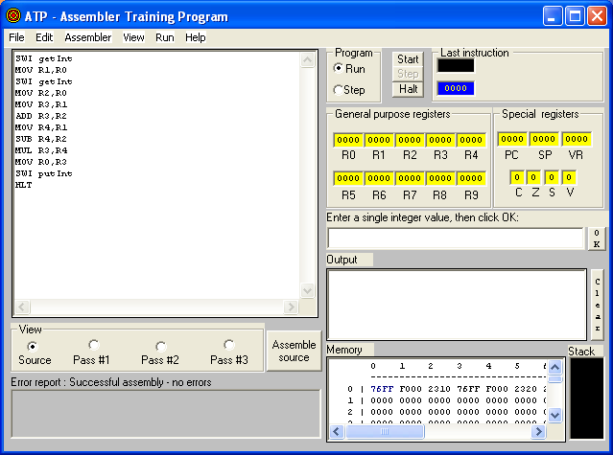

This time I tried to run the program again but then I remembered that I forgot to put the integers inside the box is needs to be placed in.



Firstly I inserted the integer 8 in the value box shown below, but this gave me an error again then I placed the integer 16 and it worked and I got no errors and I got an ‘output’ which means that my low level program successfully works as you can see on the side.

**What command s mean:**

**“SWI getInt”→ Means that the data is needed, from specific place the information will be requested.**

**“ADD R3,R1”→ This command gives the order to add the information from 3 to 1,**

**“MOV R1,R0” → This command gives the order to move the information from 1 to 0.**

**“HLT”→ This is very simple command that gives an order to stop.**

**“SWI putInt hlt”→ And this command gives and order to move the information and then stop.**